Fast Inquiry
The Fast Inquiry function (Shift F12) allows you to do an immediate parts inquiry to Kubota. This feature is available inside the following programs:

- Parts Inquiry
  - Shortcut: PI
  - Hotkey: I
- Quick Order Adjustments
  - Shortcut: QOA
- Price File Inquiry
  - Shortcut: PFI
  - Hotkey: F
Accessing Fast Inquiry: To access the feature:

- In Parts Inquiry (PI/I):

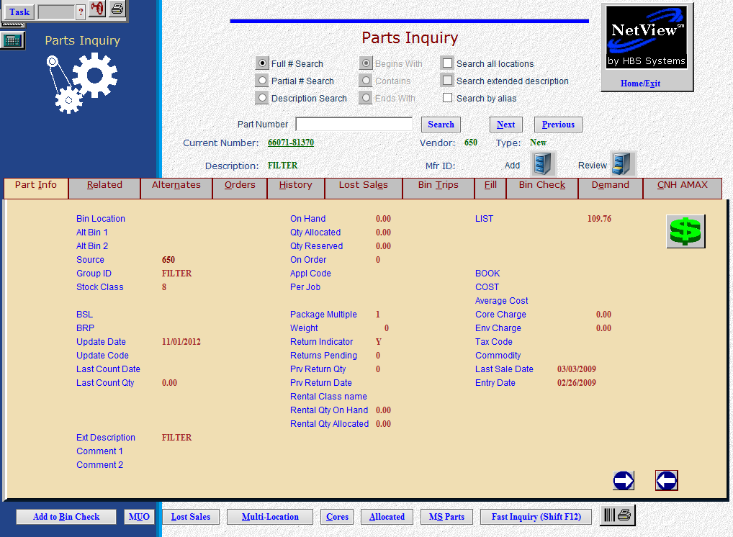

  - Fill in a Kubota part number
  - Click on the “Fast Inquiry” button or hit “Shift F12” on the keyboard.
- In Price File Inquiry (PFI/F)

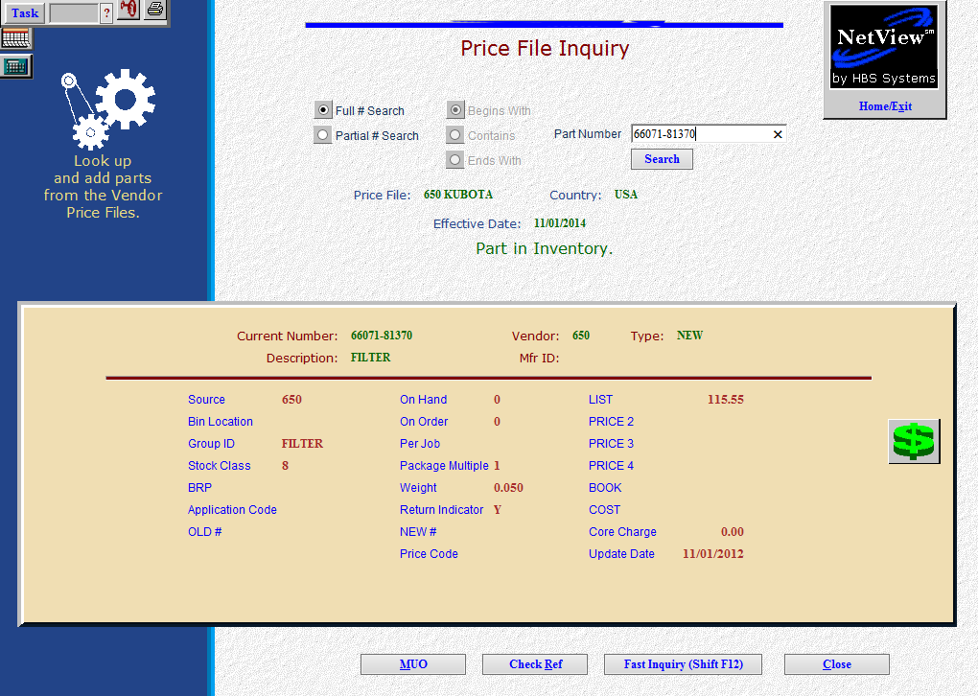

  - Enter a Kubota part number.
  - Click the Fast Inquiry button at the bottom of the screen or hit “Shift F12” on the keyboard.
- In Quick Order Adjustments (QOA)

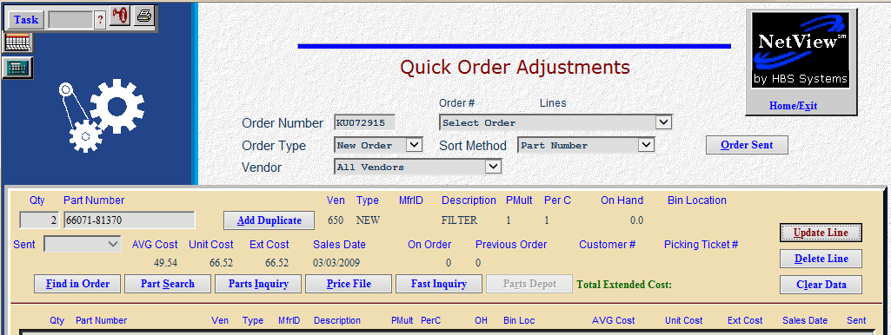

  - Enter a Kubota part number.
  - Click the Fast Inquiry button on the order line or hit “Shift F12” on the keyboard.

Using Fast Inquiry: The resulting screen shows as below:
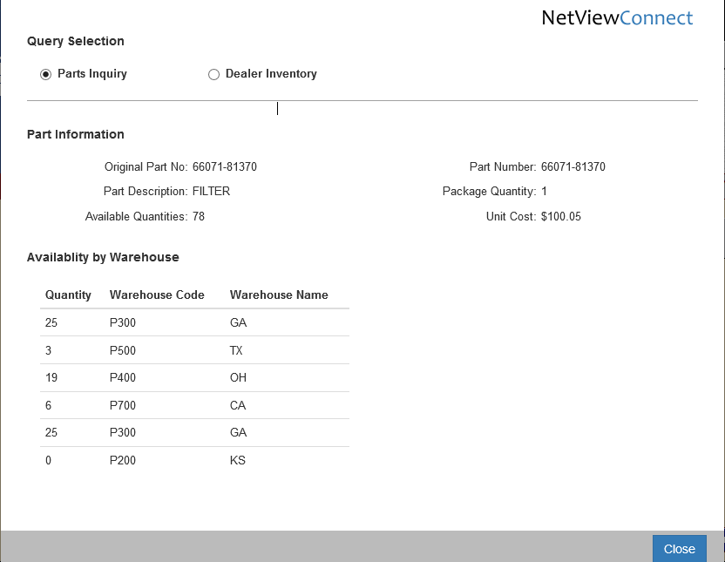
- Parts Inquiry: The inquiry initially returns the Parts Inquiry info. This includes:
  - Original part number
  - Description
  - Package quantity
  - Available quantities at Kubota, shown by:
    - Warehouse Code
    - Name
  - Unit Cost
- Dealer Inventory: Click on “Dealer Inventory” to find the part number in a dealer’s inventory

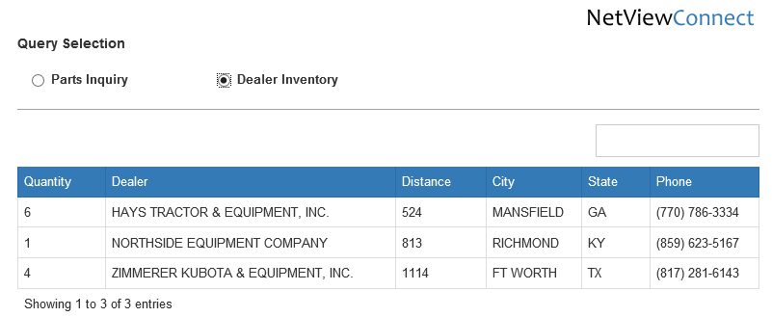

  - The Dealer Inventory info includes:
    - The quantity they have
    - The dealer’s name
    - The dealer’s distance from your dealership
    - The city
    - The state
    - The dealer’s phone number.

